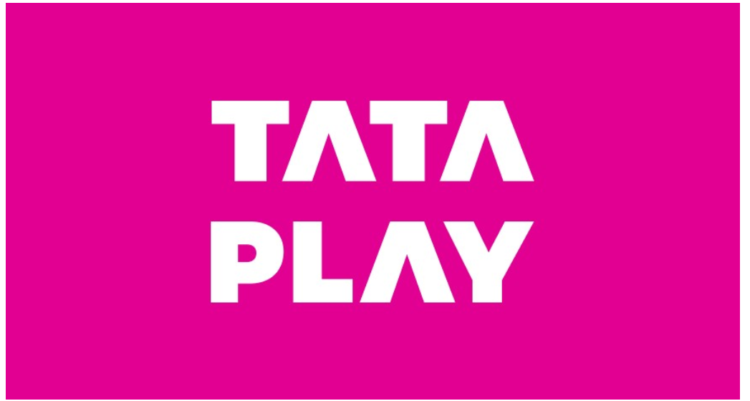Dr. Nitin Gupta

Associate Professor, School of Management, NorthCap University

About TATA PLAY

Tata Play Limited (formerly known as Tata Sky Limited), is a joint venture between Tata Sons Private Limited and TFCF Corporation (formerly known as Twenty-First Century Fox, Inc., and now a part of the Walt Disney Company). Incorporated in 2001 and initiating services in the year 2006, Tata Play is one of India's leading content distribution platforms providing Pay TV and OTT services. Tata Play was one of the first Direct to Home operators to launch customized channel packs & ala-carte channels along with multiple products and platform services that helped redefine content consumption and viewing experience of its subscribers.

Tata Play forayed into the OTT aggregation space with the introduction of Tata Play Binge - a unique platform that brings diverse OTT apps like Amazon Prime Video, Disney+ Hotstar, Sony LIV, Zee5, Voot Select, Voot Kids, ShemarooMe, SunNxt, Hungama Play, Eros Now, CuriosityStream, Epic On & Docubay onto a single user interface while offering the flexibility of single subscription and single payment. Tata Play Binge can be accessed through the Amazon Fire TV Stick- Tata Play Edition, Tata Play Binge+ Smart Set Top box powered by Android TV and Tata Play Binge mobile app.

Tata Play has footprints Pan India with 23 million connections.

TATA and TATA PLAY are trademarks of Tata Sons Private Limited.

Controversy

Sony issues strong statement against Tata Sky for switching off 32 channels

Tata Sky had removed the Sony channels, apart from three channels of India Today Network, including Aaj Tak on Monday, over pricing issues, resulting in a furore on social media. Irate Tata Sky subscribers took to Twitter and Facebook to vent their anger, asking for the decision to be reversed immediately.

“Commercial negotiations with the broadcasters (SPN and India Today Network) broke down as what they were seeking would have forced us to hike our prices. Hence, we have had to drop a few channels while keeping the popular ones on. We request our subscribers to bear with us, as we are doing this in their best interest,” said Harit Nagpal, CEO & MD of Tata Sky.

# Tata Sky faces backlash for calling NaMo TV Hindi news channel; retracts after complaints

ata Sky had earlier tweeted that the NaMo TV is a Hindi news service which provides the latest news on national politics. The DTH provider has removed the tweet now following the debates over the code of conduct as elections are around the corner. Upon several complaints on Twitter, Tata Sky had earlier said that the channel was added as a launch offer. What possibly enraged the consumers was Tata Sky’s next statement which went on to say, “There is no option to delete the individual channel.”

Airing on DTH channel number 512, NaMo airs BJP’s election rallies, speeches etc and its launch was announced by Narendra Modi himself on 31 March 2019. “Capture the colours of elections… Watch the dance of democracy… Say NaMo again with NaMo TV,” the party said in a tweet on the launch.

HISTORY

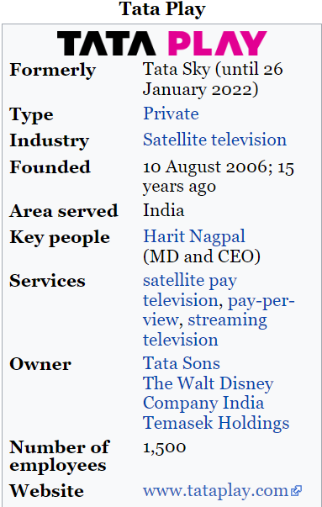

Tata Sky was an equity strategic alliance in the nature of a joint venture between the Tata Group and 21st Century Fox, which owned 80% and 20% stakes respectively[[3]](https://en.wikipedia.org/wiki/Tata_Play#cite_note-3) until 2008, when Singapore-based Temasek Holdings picked up a 10% stake in Tata Play from the Tata Group. Tata Sky was incorporated in 2001, but launched services on 8 August 2006.[[4]](https://en.wikipedia.org/wiki/Tata_Play#cite_note-4)

Tata Sky's parent company, 21st Century Fox, formerly owned an international group of DTH businesses that include Sky Italia in Italy and Sky UK in United Kingdom. The company uses the Sky brand under a licence from Sky.

Tata Sky partnered with Ericsson to launch the first Video on Demand (VOD) services in India in 2012.

On 9 January 2015, Tata Sky became the first Indian DTH operator to offer 4K set-top-boxes to its consumers.

On 20 March 2019, The Walt Disney Company completed acquisition of 21st Century Fox, making them their new 30% stakeholder, replacing 21st Century Fox.

On 26 January 2022, Tata Sky was rebranded into Tata Play as the company decided to drop the 'Sky' brand name after 15 years.

In March 2009, Tata Sky became the first Indian DTH service provider to be awarded the ISO 27001: 2005 accreditation, the benchmark for information security. ISO 27001:2005 is an international standard that provides specifications and guidance for the establishment and proper maintenance of an Information Security Management System (ISMS).

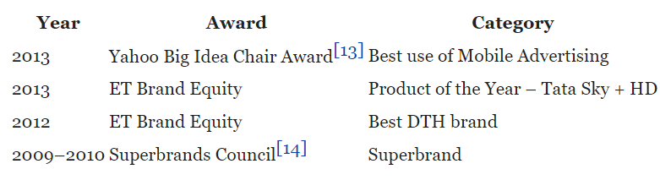

Characteristics of services provided by Tata Sky

* Intangibility: As service's nature is intangibility, therefore manufacturing and service delivery is more complex than a product. In case of tata sky intangibility is high
* Inseparability: Inseparability is a significant characteristic that distinguishes a service from a product according to the simultaneous production and consumption. In case of tata sky inseparability is high
* Perishability: Perishability is one of the major characteristics of service, that it can't be stored for later use or sale (No inventory). Besides the best efforts to standardise a service by a service provider, there are always subtle differences in the level of service given. In case of tata sky perishability is high
* Variability: Due to the service's variability, it's difficult to be controlled, because it greatly relies on the service's provider, moreover when, where and how it's provided. There are certain standards set on quality that are expected from the staff. Similarly, customer satisfaction surveys are done to constantly improve the service. In case of tata sky variability is high

INTRODUCTION TO DOOR TO HOME SERVICES

Indian Direct-To-Home (DTH) TV industry has been growing at rapid pace since the inception of commercial services in 2003 on the back of huge investments by the existing and new players. The DTH industry has defied the global trend of economic crisis and posted significant growth in 2008. Thanks to the superior audio and video quality, the DTH services are now in a position to attract a large number of subscribers. On analysis of “Indian DTH Market Forecast to 2012”, the number of DTH subscribers is projected to grow at a CAGR of around 28% during 2010- 2012. Presently, the DTH subscribers constitute only a small proportion of the total TV household in the country, representing a vast future growth potential.

The average Indian’s disposable income and purchasing power has risen to never before levels. The Indian entertainment and media industry is also not far behind. It is estimated that a worth of Rs.450 billion with a CAGR of 18% over the next five years. There has been huge growth in the number of DTH households but, for the entire furore, the market has not accelerated as it was expected to. India’s penchant for DTH has been fuelled by economic growth. India is getting wealthier and, as a result, the population is now earning more, meaning that they have more disposable income to spend on items such as TV sets. In fact, the Indian TV market is massive. There are 130 million TV households in the country.

Currently, the Indian DTH market is being served by six private players - Dish TV, Tata Sky, Sun Direct, Big TV, Airtel Digital TV and Videocon D2H. Doordarshan is also available but this is a free DTH service provider. All providers are investing huge amounts of money in the promotion and marketing of DTH services in the country

The main objective of the research is to find the gap between the expectation and perception of the DTH services provided to the customers. It is being justified why this industry is being selected. Indian Direct-To-Home (DTH) TV industry has been growing at rapid pace since the inception of commercial services in 2003 on the back of huge investments by the existing and new players.

GAP 1: LISNING GAP

Provider gap 1, *the* listening gap, is the difference between customer expectations of service and company understanding of those expectations. A primary cause in many firms for not meeting customers' expectations – that is, the customer gap – is that the firm lacks accurate understanding of exactly what those expectations are. Many reasons exist for managers not being aware of what customers expect: They may not interact directly with customers, they may be unwilling to ask about expectations, or they may be unprepared to address them. Closing the listening gap requires that management or empowered employees acquire accurate information about customers' expectations. Customer expectations must be assessed accurately before new services are developed, and they must be tracked after the services are introduced.

Closing gap 1 through research and effective management of customer relationships is necessary, but not sufficient, for achieving service excellence. Even when a company has a thorough and ongoing understanding of its customers' expectations, it is still very possible, in fact, quite easy, to fail to deliver quality service. Focusing on gap 2, the design and standards gap, is the next step toward ensuring against such failure. This gap is concerned with translating customer expectations into actual service designs and developing standards to measure service operations against customer expectations.

lthough a company may have closed both the listening gap and the service design and standards gap, it may still fall short of providing service that meets customers' expectations if it is unable to deliver service in the way the service was designed. Gap 3, the service performance gap, must also be closed to make sure there is no discrepancy between customer-driven service design and standards and actual service delivery. Even when guidelines exist for performing service well and treating customers correctly, high-quality service performance is not a certainty. Standards must be backed by appropriate resources (people, systems, and technology) and also must be enforced to be effective – that is, employees must be measured and compensated on the basis of performance along those standards. Thus, even when standards accurately reflect customers' expectations, if the company fails to provide support for those standards – if it does not facilitate, encourage, and require their achievement – standards do no good. When the level of service delivery falls short of the standards, it falls short of what customers expect as well. Narrowing gap 3 by ensuring that all the resources needed to achieve the standards are in place reduces the customer gap.

Even when a firm has done everything suggested by the other three gaps to ensure service quality, there can still be a failure to meet customer expectations if communications about the service do not match with what is delivered. Thus, the final provider gap that must be closed is the *communication gap*, or gap 4. This gap focuses on the difference between service delivery and what is communicated externally to customers through advertising, pricing, and other forms of communications.

Listening Gap

Adequate customer research

Tata Sky had also set up sales and service dealers (SSDs) across semi-urban and rural markets of India. The company adopted aggressive promotional strategies including television commercials (TVCs), outdoor, radio and Internet advertising. ata Sky offered different channel packages so that consumers could choose their favorite channels and pay only for those they wanted to watch. The company had also built a wide distribution network to reach every household in India. It also entered into agreements with ITC's e-Choupal, Godrej's Aadhar and Indian Oil Corporation to extend its reach to the rural consumers.

• Awesome service: When I purchase the connection they treated me like a special person. I received call directly from their customer care several times Just to confirm whether the installation has been done or whether I need any assistance. They also call for feedback. Technician was very knowledgeable and behave in professional manner. Fast and reliable service. Infact I never spoken to any senior person of their customer care department.  
  
• Amazing picture quality. Supports 7.1 speaker output. Dolby digital and digital plus sound as well. Dish TV supports 5.1 and doesn’t have Dolby sound. So any HD channel with Dolby surround sound may not work.  
  
• User interface : Beautiful , user friendly and Lag free interface. Unique and exclusive feature is that they provide info about Country origin , Episode, cast, Year, short story about Movies and Serials. I didn’t knew James Bond movie series was made by UK production house. Very informative.

Upward communication

#### **Helpline Numbers**

[[Phone Calling](tel:1860%20120%206633)1860 120 6633[Phone Calling](tel:1860%20120%206633)1860 500 6633](tel:1860%20120%206633)

## **WhatsApp for instant support**

### **To assist you better and keep you updated, we are now on WhatsApp too**

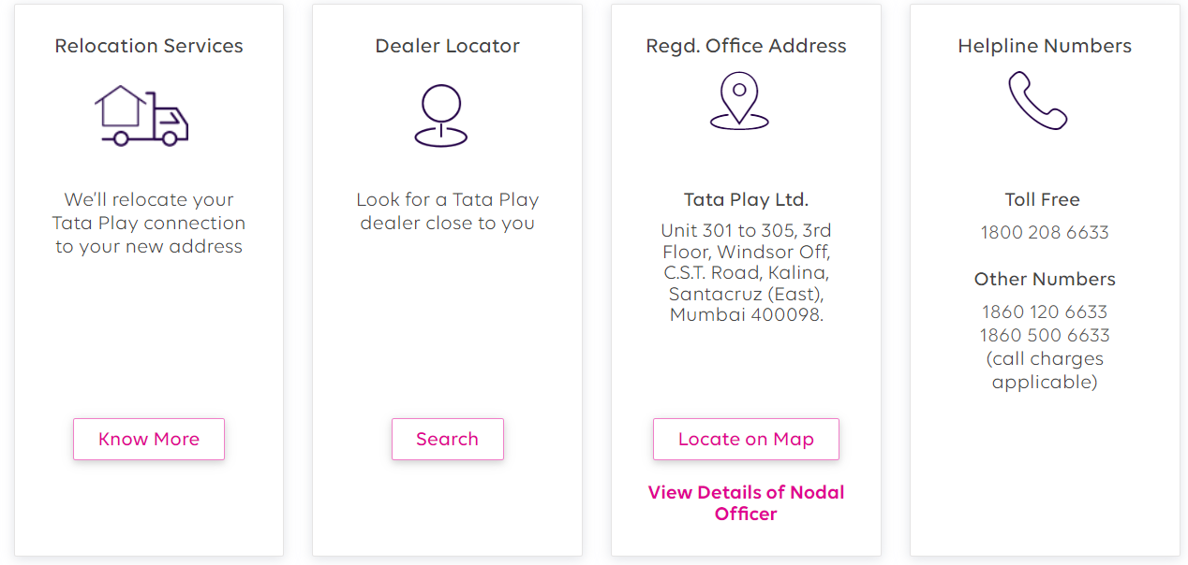

Service recovery

At the time the servise providers across industries are looking to increase their average revenue per user(ARPU), Tata Play is reducing it. The company is reducing the cost of channel bouquets and packs for its user in order to retain them in an over-the top (OTT) content dominated era.

GAP 2 SERVICE DESIGN AND STANDARDS GAP

Tata sky doesn’t have gap 2 because

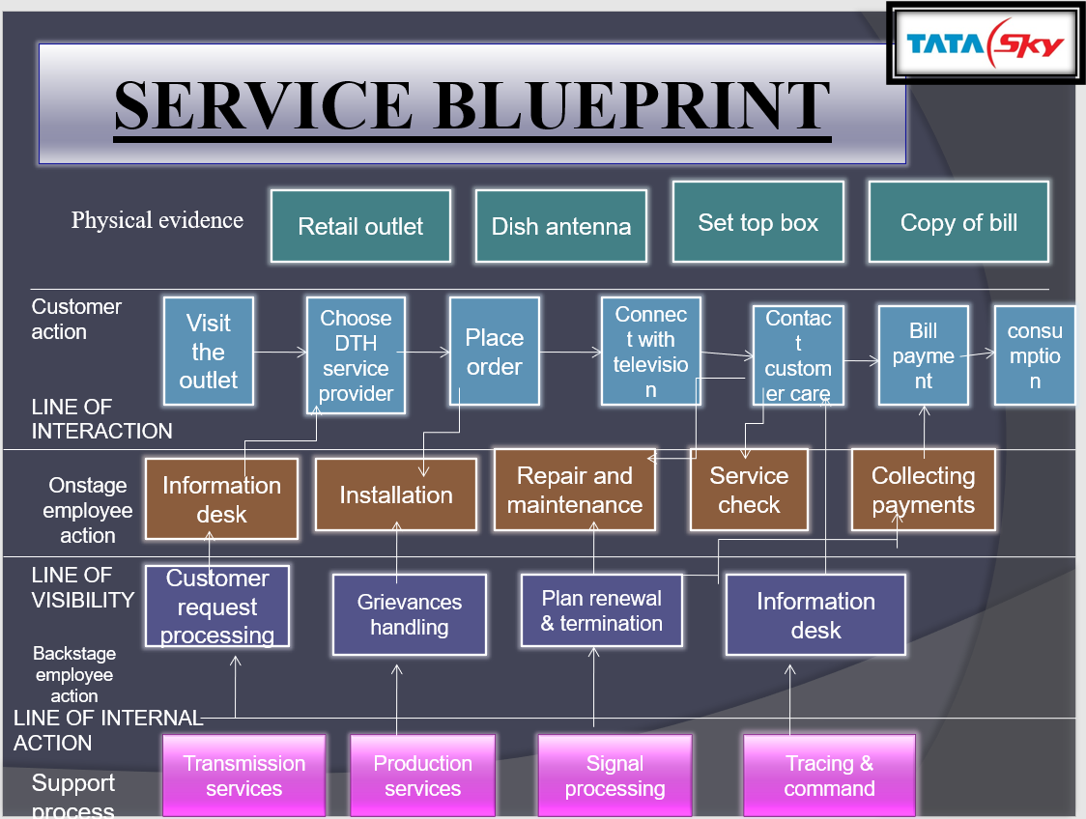

Customer-driven service designs and standards

* Good service design standard

If we are worried about paying for different OTT platforms, Tata Sky has solved that issue for us with the ‘Tata Sky Binge’ service. It was announced way back in 2019 and has evolved into something better now. The company offers two different plans to the users which come for Rs 149 and Rs 299. The Rs 299 plan is something you should go for if you want to consume content from every platform. However, if you want to watch from fewer platforms and are okay with consuming all of the content on your mobile phone, you can go for the Rs 149 plan from the company. Purchasing standalone subscriptions of even three to four of these platforms for a year would make you pay around Rs 3,000 or more, which is very expensive. Thus, the Tata Sky Binge service makes more sense in 2021 than ever.

* Tata Sky focusing on customer requirement

As Tata Sky’s leaders looked to set the standard for premium pay-tv, they turned to NDS (now part of Cisco), and today Tata Sky and Cisco work together to release a new generation of TV experiences in India. Tata Sky’s interactive lineup under the “Active” brand includes:

* Active English, which provides conversational English education
* Active Fun Learn, which offers learning games, arts and crafts for children
* Active Music, which provides 10 channels of music day and night
* Active Games, which users can play with the TV remote
* Active Cooking with recipes and cooking tips from master chefs across India
* Showcase, which offers pay-per-view movies

“Tata Sky have several interactive services under our Active brand, including an educational channel for children, interactive gaming, cooking, English lessons, music, and pay-per-view movies,”. Tata Sky have been able to capture a unique position in the subscriber’s mind, where they know that Tata Sky means more than just TV. And over the years, we’ve been able to monetize these services.

* Physical Evidence and service escape

Tata sky successful in developing tangibles in line with customer expectations. Tata Sky provide Dish antenna, Set top box and bills in form of physical evidence. For consumers visiting a service or retail store, the service environment is the first aspect of the service that is perceived by the customer and it is at this stage that consumers are likely to form impressions of the level of service they will receive and Tata sky is prominent in providing that service. Tata sky design their servicescapes to add an atmosphere that enhances the customer experience and that will affect buyers' behavior during the service encounter. The customer's interactions with a service provider typically involve face-to-face contact with service personnel, in addition to interactions with the physical elements of the service environment including the facilities and equipment.

GAP 3 PERFORMANCE GAP

* 1. Deficiencies in human resource policy.

In Tata sky there are no work life balance at all and in the field service department people have to work 24/7 and there are no supporting employees so there is deficiency in human resource.

* 1. Customers not fulfilling roles.

If u are using Tata sky you should prefer tata sky to your neighbour and friends but the customer did not do that and if the customer is facing any difficulty regarding operating the tata sky customer responsibility to told the issue to the company so company can resolve the issue in update but many customers didn’t tell that.

* 1. Problem with service intermediaries.

The most significant problem faced by the customer is signal problem which should be resolved under an hour but intermediaries take about 4 hours to resolve the problem. The intermediaries did not told about all the plans they only tell those plans which have high profit margin and they force the customer to buy those plans . They didn’t told all the offers which company are giving to customes so we can say they therea re problem with service intermediaries.

* 1. Failur to match supply and demand.

In some places there are failure to match supply and demand because different companies are offering many good offer as compared to tata sky so people are shifting to other brands and there are many pleces where tata sky is not working properly and due to service officer people are shifting to other brands so there is failure to match supply and demand.

Avoid tataplay Binge Plus like the plague. The image quality of supposedly 4k STB is worse than my earlier HD STB. It is an android device so if like me you have only iphones at your home you will need to BORROW someones phone to even activate it and later in case of any service visit by technician (who never comes) and also it uses enormous amounts of data even for channels you have already subscribed to. Icing on the cake are their HORRIBLE CALL CENTRE guy…. They will only say हमें खेद है or ‘Sorry for the inconvenience’ and keep blabbing for hours but do nothing to redress your issues. I have been a loyal TATA SKY subscriber for more than 14 years now (since inception) but now switching over to other service providers.

**No, it is Not Absolutely Not Worth it at all . Remember One thing all Satellite DTH Services Don't Work During Rains or During Cloudy Season . So If You Still Want to Buy Tata Play it is Your Wish and Your Risk . Tata Play is the Highest Priced DTH Service in India**

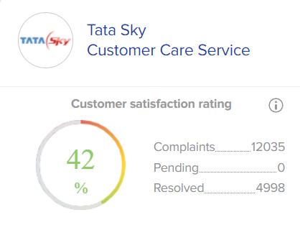

GAP 4 COMMUNICATION GAP

Tata Sky launched region-specific campaigns in Kerala, Punjab and West Bengal to connect with potential customers in in these regions. The 360-degree campaign derives inspiration from the inherent local culture and insights of the audiences in each state and was delivered using high reach and impactful mediums across ATL. The campaigns targeted the local Tata Sky dealers with customised communications. Taking a hyper-local approach, three different ad campaigns were created for Kerala, Punjab and West Bengal, imbibing the regional languages that resonate with the local consumer in each region. The ad campaigns share a common messaging of how a Tata Sky connection can add value, not just for an individual but for the entire family.

With over 22 million subscribers, Tata Sky, plans to further win the confidence of potential customers across the country with its pioneering technology and distinctive customer service.

Tata Sky, India’s leading content distribution platform has launched a new integrated campaign ‘Full Family Jingalala’ to tell families about the possibilities which can open for them through Tata Sky. Tata Sky, India’s leading content distribution platform has launched a new integrated campaign ‘Full Family Jingalala’ to tell families about the possibilities which can open for them through Tata Sky. we have put the man of the family in the centre and recognise that he wants to give better things to his family as they move up in life. With a simple change like getting a Tata Sky connection at home, he can create a much bigger impact on his family’s happiness which goes way beyond the act of just consuming content.

Tata Sky takes direct responsibility for installing and servicing the

hardware at every subscriber's home, thereby ensuring the highest levels

of customer service. Watch a wide array of your favorite television channels in

DVD quality picture and CD quality sound

• Get your favorite recipes when you want on Actve Cooking

• Play interactive games on your TV with Actve Games

• Order once and enjoy the latest movies with a single ad-break through the day on Showcase

• Learning games for children on Actve Wizkids

• Find out what each day has in store for you with Ganesha

Speaks

Reater control

• Watch cricket with multiple camera angles, choice of

commentary language and highlights on-demand only on

Actve Sports

• Go directly to your favorite news section on Actve STAR

News

• Regulate what your children watch on TV with parental

control

Greater convenience

• Get a 7-day listing of all programmes on TV with guide

• Catch a news story as it breaks, simultaneously on four

channels on Actve Newsroom

• Use the search & scan banner to find out what’s playing on

other channels without changing the channel you are

watching

• Enjoy fixed channel positions and uniform volume levels

across all channels

• Experience uninterrupted viewing. No longer get affected

Customer care of tata sky is best followed by DishTV and airtel.

Appropriate pricing

Pricing of tata is good. It is not too cheap or too expensive.

Tata Sky one of the best DTH service provider in the country with various affordable and cheapest packages. In order to select your cheapest and best Tata Sky package you can visit Tata Sky official browse different packages and select the best package as per your budget and requirement. Recharge according to everyone's preference which sometimes would be costly. **Tata sky has various SD, and HD set-top box prices ranging from Rs. 1,300 to Rs. 4,000**. Standard installation is free, one year warranty. First year service free.

Conclusion

There is only gap 3 in tata sky which is performance gap. Tata sky is not preforming well. There is some lag.